Experiment 9: Cassandra Exercise – Sparkify Music Streaming
Objective
To design a query-based data model in Apache Cassandra for the Sparkify music streaming application, create optimized tables for different queries, insert sample data, and retrieve data efficiently using CQL.

Procedure
- Start the Cassandra Docker container.
- Connect to Cassandra using cqlsh.
- Create the sparkify keyspace.
- Create three tables optimized for different queries.
- Insert sample music streaming data.
- Execute CQL queries to retrieve the required information.
- Verify the query results.
- Exit the Cassandra shell.

Code
1. Create Keyspace
CREATE KEYSPACE IF NOT EXISTS sparkify
WITH REPLICATION = {
'class':'SimpleStrategy',
'replication_factor':1
};

USE sparkify;

2. Create Tables
Table 1: Songs Played in a Session
CREATE TABLE song_info_by_session (
session_id INT,
item_in_session INT,
artist TEXT,
song TEXT,
length DECIMAL,
PRIMARY KEY (session_id, item_in_session)
) WITH CLUSTERING ORDER BY (item_in_session ASC);

Table 2: User Song Playing History
CREATE TABLE song_playing_history_by_user (
user_id INT,
session_id INT,
item_in_session INT,
artist TEXT,
song TEXT,
first_name TEXT,
last_name TEXT,
PRIMARY KEY ((user_id, session_id), item_in_session)
) WITH CLUSTERING ORDER BY (item_in_session DESC);

Table 3: Users Who Listened to a Song
CREATE TABLE who_listened_to_song (
song TEXT,
user_id INT,
first_name TEXT,
last_name TEXT,
PRIMARY KEY (song, user_id)
);

3. Insert Sample Data
INSERT INTO song_info_by_session
(session_id,item_in_session,artist,song,length)
VALUES
(100,1,'The Beatles','Hey Jude',7.11);

INSERT INTO song_info_by_session
(session_id,item_in_session,artist,song,length)
VALUES
(100,2,'Led Zeppelin','Stairway to Heaven',8.02);

INSERT INTO song_info_by_session
(session_id,item_in_session,artist,song,length)
VALUES
(100,3,'Pink Floyd','Comfortably Numb',6.53);

INSERT INTO song_playing_history_by_user
(user_id,session_id,item_in_session,artist,song,first_name,last_name)
VALUES
(1,100,1,'The Beatles','Hey Jude','John','Doe');

INSERT INTO song_playing_history_by_user
(user_id,session_id,item_in_session,artist,song,first_name,last_name)
VALUES
(1,100,2,'Led Zeppelin','Stairway to Heaven','John','Doe');

INSERT INTO song_playing_history_by_user
(user_id,session_id,item_in_session,artist,song,first_name,last_name)
VALUES
(1,100,3,'Pink Floyd','Comfortably Numb','John','Doe');

INSERT INTO who_listened_to_song
(song,user_id,first_name,last_name)
VALUES
('Hey Jude',1,'John','Doe');

INSERT INTO who_listened_to_song
(song,user_id,first_name,last_name)
VALUES
('Hey Jude',2,'Jane','Smith');

4. Execute Queries
Query 1: Get all songs played in Session 100
SELECT *
FROM song_info_by_session
WHERE session_id = 100;

Query 2: Get all songs played by User 1 in Session 100
SELECT *
FROM song_playing_history_by_user
WHERE user_id = 1
AND session_id = 100;

Query 3: Find all users who listened to "Hey Jude"
SELECT *
FROM who_listened_to_song
WHERE song = 'Hey Jude';

5. Exit Cassandra
EXIT;
Screenshot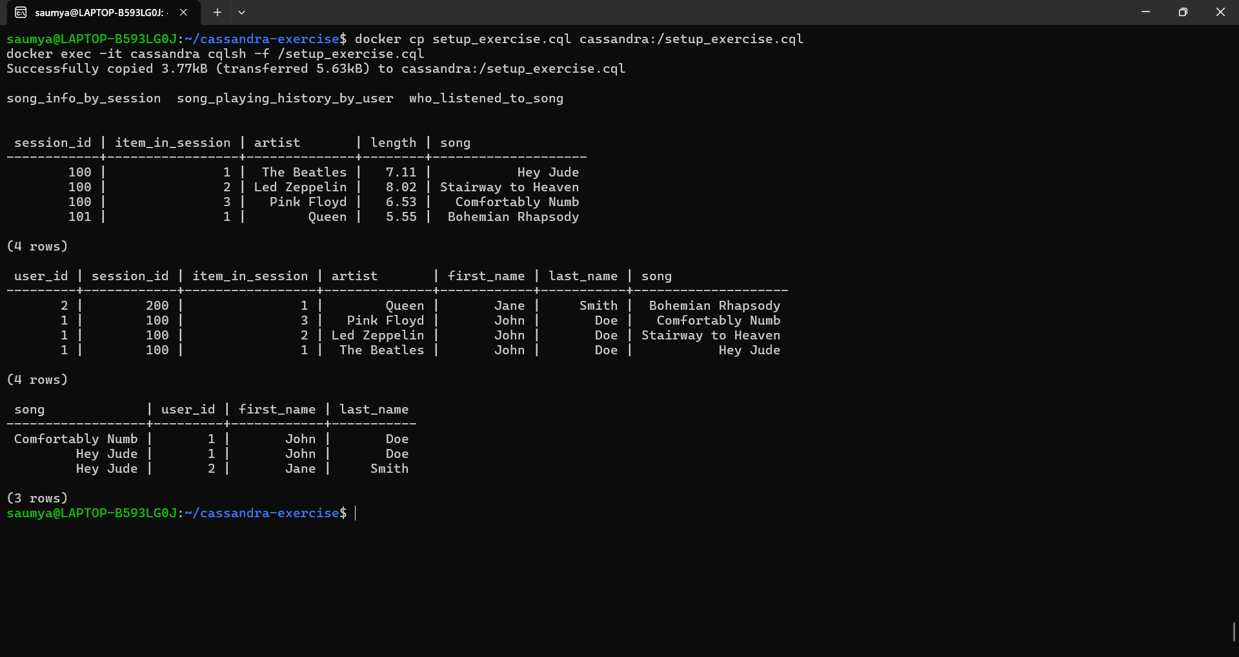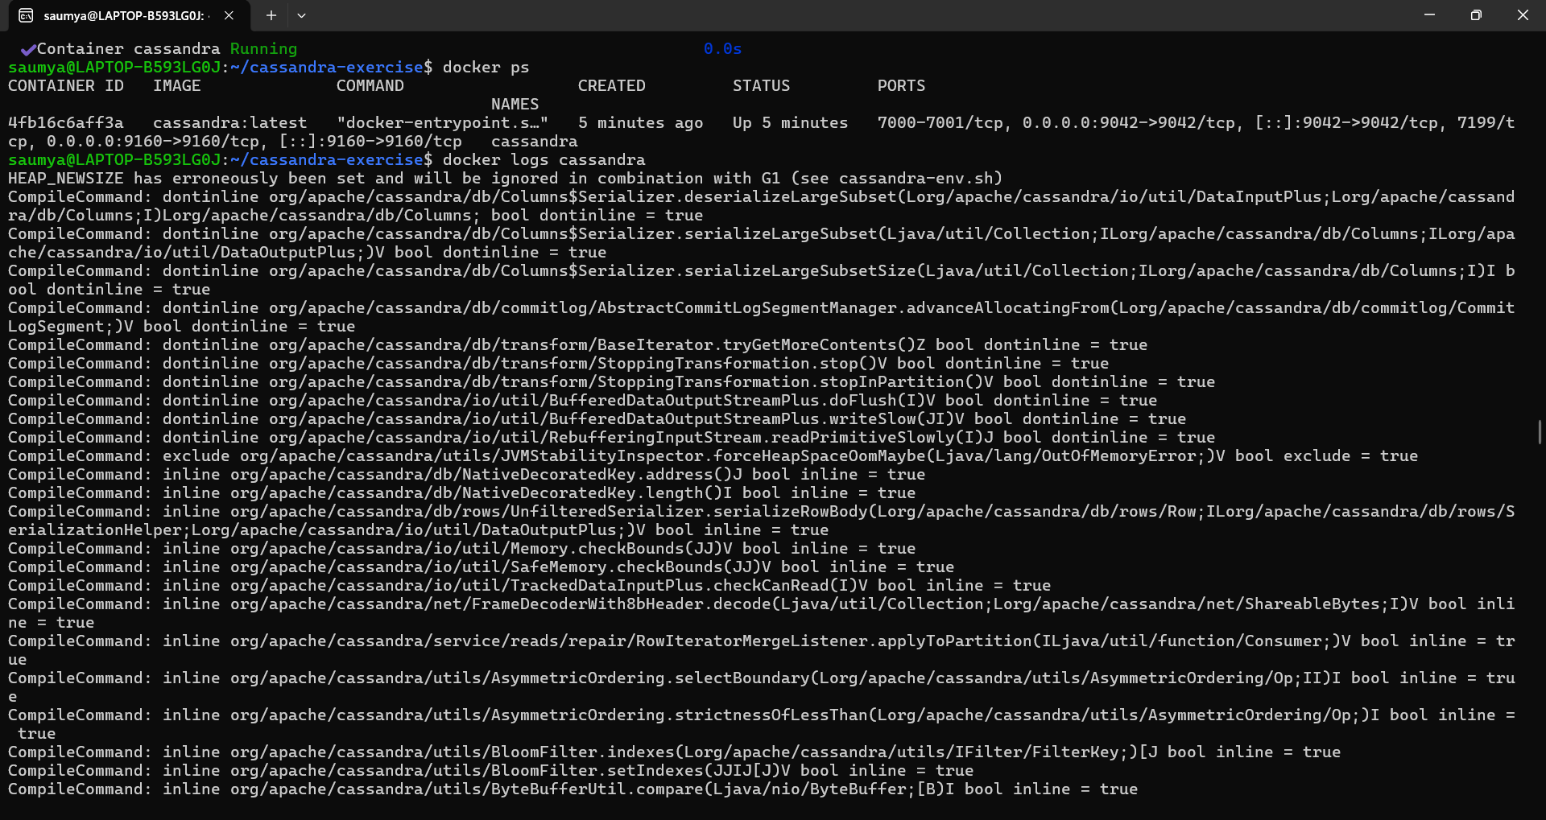
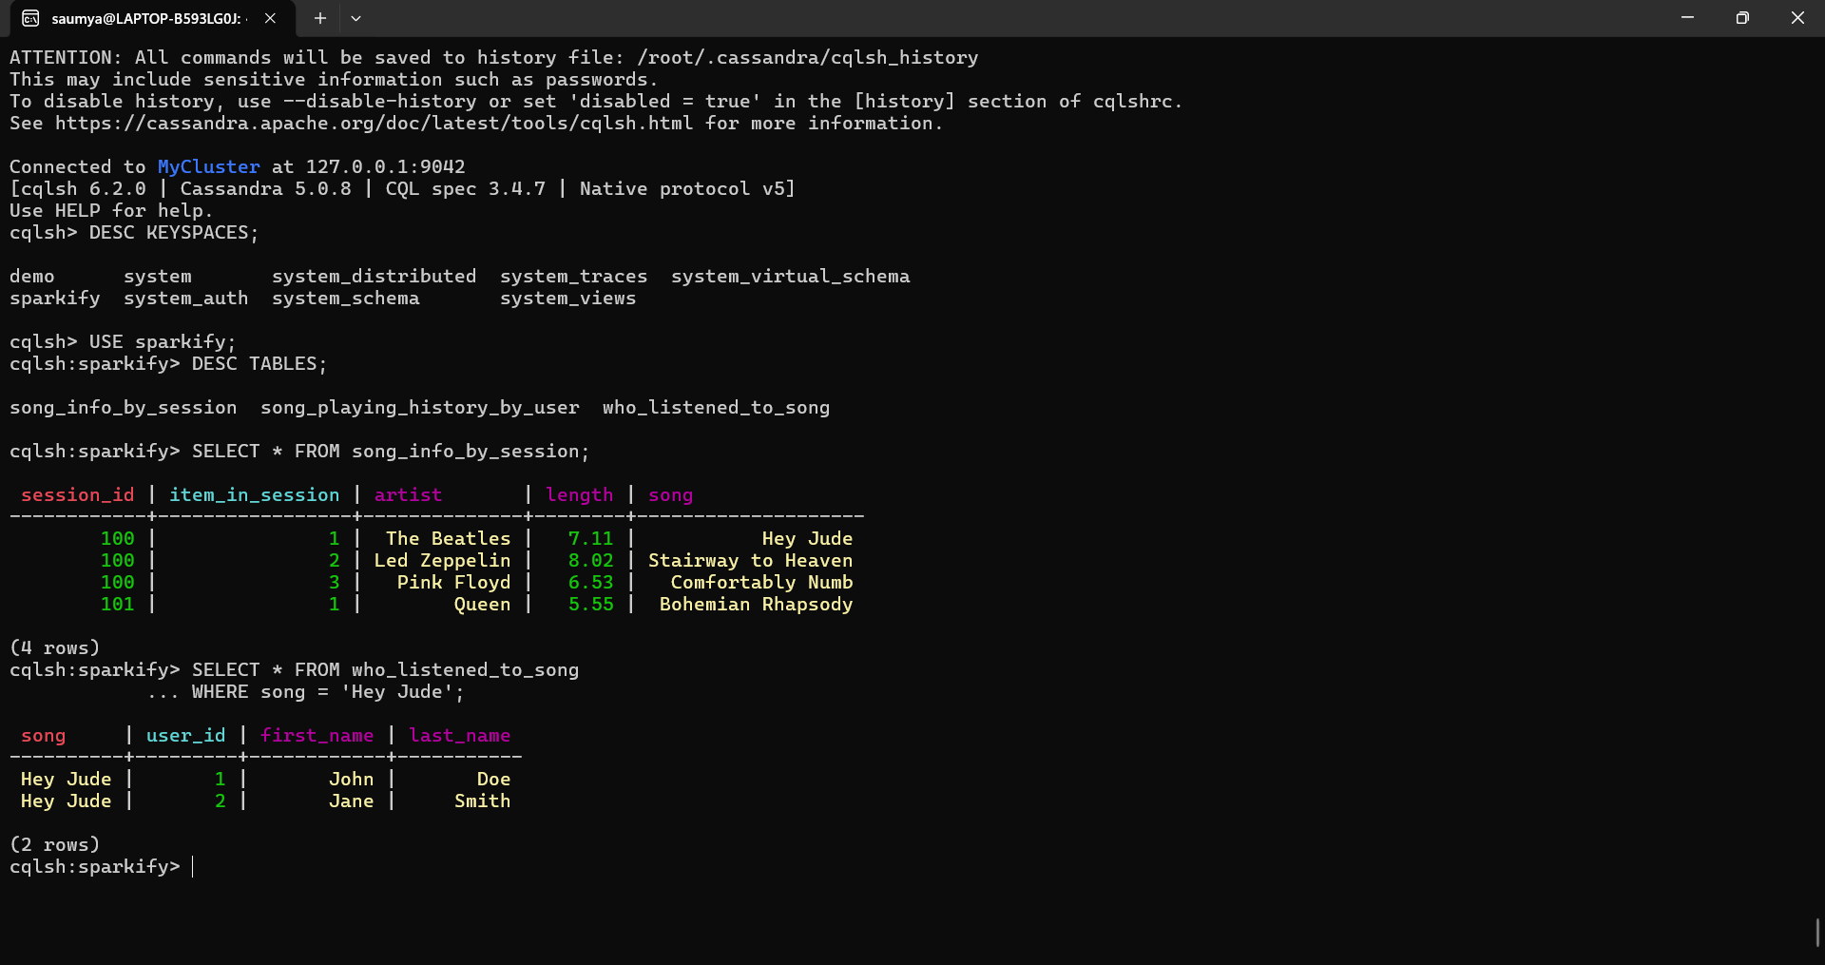
Conclusion
The Sparkify music streaming database was successfully implemented using Apache Cassandra. Three query-specific tables were created to support efficient retrieval of session-based song history, user listening history, and users who listened to a particular song. Sample data was inserted and the required CQL queries were executed successfully, demonstrating Cassandra's optimized query-driven data modeling and high-performance data retrieval for distributed applications.

Viva Questions:
1. Data Modeling: Why do we have 3 separate tables instead of 1 table with JOINs?
Answer:
Cassandra does not support JOIN operations like relational databases. Tables are designed based on specific queries. Each table is optimized for a particular query, providing faster data retrieval.

2. Partition Keys: What would happen if we used user_id alone as the partition key for Query 2?
Answer:
Using only user_id as the partition key would store all sessions of a user in the same partition. This would:
- Create very large partitions.
- Reduce query performance.
- Make it difficult to efficiently retrieve data for a specific session.
Using (user_id, session_id) distributes data better and makes queries faster.

3. Clustering Order: Why use ASC for one table and DESC for another?
Answer:
- ASC (Ascending): Displays songs in the order they were played (first to last).
- DESC (Descending): Displays the most recently played songs first, which is useful for viewing recent user activity.
The clustering order is chosen based on the application's query requirements.

4. UPSERT Behavior: What happens when you INSERT a row with an existing PRIMARY KEY?
Answer:
Cassandra performs an UPSERT (Update + Insert).
- If the primary key does not exist, a new row is inserted.
- If the primary key already exists, the existing row is updated with the new values.
- No duplicate rows are created.
Example:
INSERT INTO song_info_by_session
(session_id, item_in_session, artist, song, length)
VALUES (100,1,'The Beatles','Let It Be',4.03);
This replaces the previous song at (session_id=100, item_in_session=1).

5. Consistency: What is the difference between CONSISTENCY ONE and CONSISTENCY ALL?
CONSISTENCY ONE | CONSISTENCY ALL
Requires only one replica to respond. | Requires all replicas to respond.
Faster read/write operations. | Slower operations.
High availability. | Lower availability if any replica is down.
Data may not always be the latest version. | Ensures the most up-to-date data.
Summary:
- CONSISTENCY ONE: Fast, high availability, eventually consistent.
- CONSISTENCY ALL: Slow, strict consistency, all replicas must agree.

